**Address Book REST API**

**Database:** CassandraSetup, Host: 127.0.0.1

Step 1) Create a Keyspace named “example”.

Command: Create KEYSPACE “example” WITH replication = {‘class’ : ‘Simple Strategy’, ’replication_factor’ : ‘2’}

Step 2) Create a table named “addressbook”.

Command: Create table addressbook(phone bigint PRIMARY KEY, firstname text, lastname text, email text)

**External Packages Details:**

**"github.com/gorilla/mux" (Rest API Implementation Package)****"github.com/gocql/gocql" (Cassandra driver)**

Import the above two packages in GO hierarchy directory /Workspace/src/ by using the below commands.

go get **"github.com/gocql/gocql"**

go get **"github.com/gorilla/mux"**

**My Project Code:**

Get my project implementation packages from github and place them in GO Hierarchy directory /Workspace/src/

**Code Test:**

Use Postman chrome extension to test the API.

**CreateAddress:**

**URL**: localhost:12345/address/{phone}

**Http Action Method**: PUT

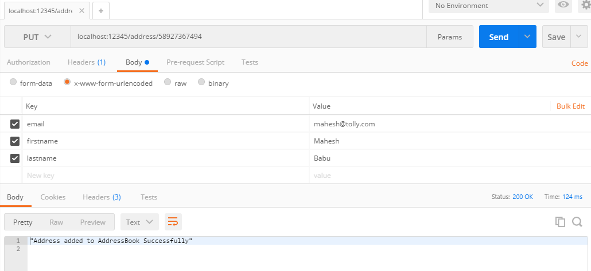

**Update Address:**

**URl:** localhost:12345/address/{phone}

**Http Action Method**: POST

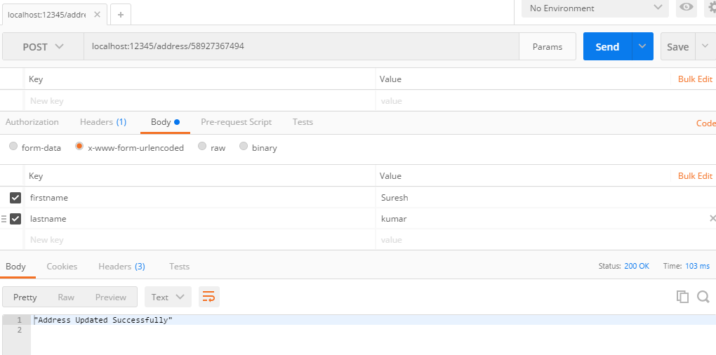

**GetAddress:**

URL: localhost:12345/address/{phone}

Http Action Method: GET

**DeleteAddress:**

URL: localhost: 12345/address/{phone}

Http Action Method: DELETE

**ImportAddress:**

URL: localhost: 12345/address/import/values1

Here values1 is a csv file.

Http Action Method: PUT

**ExportAddress:**

URL: localhost: 12345/address/export/

Http Action Methods: GET.

**Importing & Exporting AddressBook**

For Importing and Exporting data in the csv format from database and to database.

Create a csv file with four columns firstname, lastname, phone, email and details.

And these methods are called as per the requirement.

ImportAddresses - Function in AddressBook Package to Import Address Book. Pass a .CSV filename as an argument.

ExportAddresses – Function in AddressBook Package to Export Address Book.

These are sample records:

pallavi,akkineni,8446281935,pallavi@akkineni.com  
nagarjuna,nandamuri,8723857549,nagarjuna@nandamuri.com  
charan,konidella,4684739471,charan@konidella.com  
arjun,allu,7827487488,allu@arjun.com  
brahmini,nandamuri,5782758758,brahmini@nandamuri.com  
venky,daggupati,7376568831,venky@daggupati.com  
gayatri,gottumukkala,9839001263,gayatri@gottumukkala.com  
lahari,paruchuri,8778654349,lahari@paruchuri.com  
chanana,kakarla,8710845291,chandana@kakarla.com  
srujana,devineni,8979843389,srujana@devineni.com